Magnet Movement: Make a Game or Toy 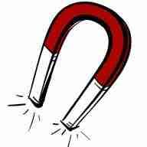
2nd Grade Design Brief
Background: You’ve had some time to experiment with magnets to get a sense of what magnets can do and the kinds of things they can pick up. You’ve learned that unlike poles attract and like poles repel. We’ve also been learning about the Engineering Design Process.
Challenge: Your challenge is to design and build a fun game or toy using magnets to create motion.
Criteria: Your game or toy must:
- Make use of a magnet to create motion
- Use a minimum of two magnets but no more than five
- Use at least one magnetic material
- Be visually appealing

Materials:
- Set of magnets
- Magnetic and non-magnetic materials such as paperclips, lids of jars, soda pop tops, pipe cleaners, twist ties, plastic bits, craft sticks, cotton balls, etc.
- Colored paper, small boxes
- Ways to make connections such as string, wire, glue, tape, rubber bands

Tools:
- Scissors
- Markers
- Hole punch

