A Model Butterfly
Kindergarten Design Brief
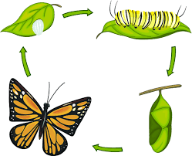

Background:
We have been learning that animals and plants change as they grow. We read The Very Hungry Caterpillar and saw a butterfly change from an egg, to a caterpillar, to a chrysalis to a beautiful butterfly. We also have been learning about pop up paper and the Engineering Design Process.

Challenge:
Your challenge is to show four stages of a butterfly’s life cycle using materials from the tinker carts. Use pop up paper to show at least one stage.

Criteria:
- The model shows 4 stages: egg, larva, pupa and adult.
- The model shows the stages in order that they happen in nature.
- At least one stage has pop up paper.

Materials:

- paper plate to serve as a base
- items from the tinker carts
- paper

Tools:

- scissors
- hole punch
- paper punch
- masking tape

- tacky glue
- glue gun
- stapler
- markers

