Magnet Structures 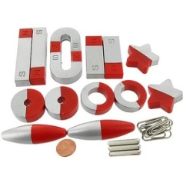
Kindergarten Design Brief
Background: You’ve had some time to experiment with magnets to get a sense of what magnets can do and the kinds of things they can pick up. Your next task is to put what you know about magnets to use by building a structure held together only with magnets.
Challenge: Your challenge is to design and build the tallest freestanding structure you can. Everything in your structure must be held together only by the magnets provided.
Criteria: Your structure must:
- Use ONLY the materials provided and only those that are attracted by a magnet
- Stand by itself and be built UP from the table/desk
- Have a name

Materials:
- Set of magnets
- Magnetic and non-magnetic materials—for example--paperclips, lids of jars, soda pop tops, nuts, bolts, springs, allen wrenches, pipe cleaners, twist ties, keys, wire, plastic bits, etc.
Tools:
- Scissors
- Snap cubes or another non-standard unit for measuring the height of the structures

Virginia Standards of Learning

K.3 – Investigate and understand that magnets have an effect on some materials, make some things move without touching them, and have useful applications.

Standards for Technological Literacy

STL 9 – Understand engineering design.
STL 11 – Apply the design process.

Cindy Zmijewski Demers | cindy@upcyclecrc.org | UpCycle Creative Reuse Center | www.UpCycleCRC.org

Name: ____________________________________
1. Which objects were attracted to a magnet and which were not?
NO
YES

2. Draw a sketch of your sculpture and/or describe it here.

How tall was your sculpture? _________________________________

What name did you give it? ____________________________________

